* Difficulty Level : [Basic](https://www.geeksforgeeks.org/basic/)
* Last Updated : 07 Jul, 2021

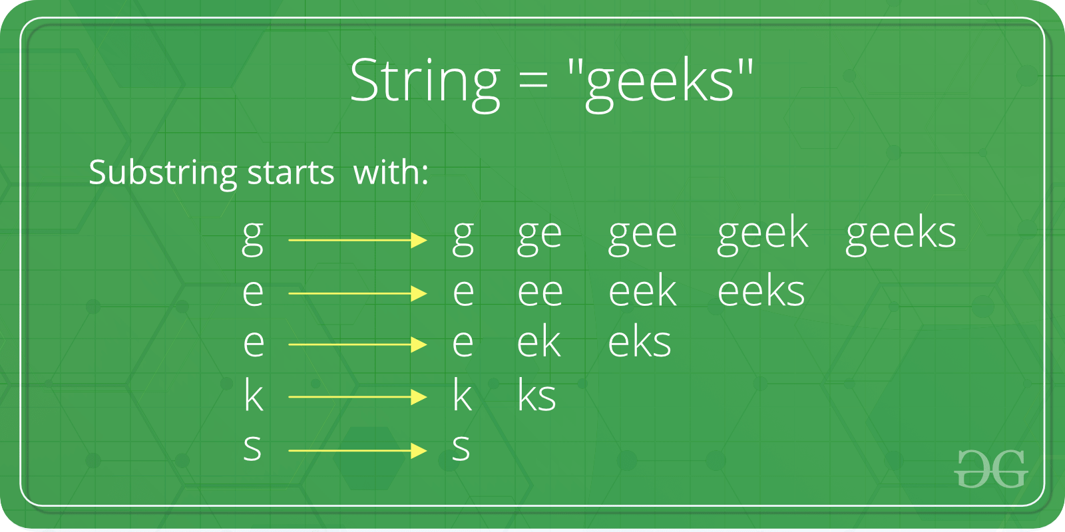

There are **two** variants of the substring() method. This article depicts all of them, as follows :

**1. String substring():**This method has two variants and**returns** **a new string** that is a substring of this string. The substring begins with the character at the specified index and extends to the end of this string. And index of substring starts from 1 and not from 0.

**Syntax :**

**public String substring(int begIndex)**

**Parameters :**

**begIndex :** the begin index, inclusive.

**Return Value :**

The specified substring.

**Java**

|  |
| --- |
| // Java code to demonstrate the  // working of substring(int begIndex)  **public** **class** Substr1 {  **public** **static** **void** main(String args[])      {            // Initializing String          String Str = **new** String("Welcome to geeksforgeeks");            // using substring() to extract substring          // returns (whiteSpace)geeksforgeeks            System.out.print("The extracted substring is : ");          System.out.println(Str.substring(10));      }  } |

**Output:**

The extracted substring is : geeksforgeeks

**2. String substring(begIndex, endIndex):** This method has two variants and **returns** a **new string** that is a substring of this string. The substring begins with the character at the specified index and **extends** to the end of this string or up**to endIndex – 1** if the second argument is given.

**Syntax :**

**public String substring(int begIndex, int endIndex)**

**Parameters :**

**beginIndex :**  the begin index, inclusive.

**endIndex :**  the end index, exclusive.

**Return Value :**

The specified substring.

**Java**

|  |
| --- |
| // Java code to demonstrate the  // working of substring(int begIndex, int endIndex)  **public** **class** Substr2 {  **public** **static** **void** main(String args[])      {            // Initializing String          String Str = **new** String("Welcome to geeksforgeeks");            // using substring() to extract substring          // returns geeks          System.out.print("The extracted substring  is : ");          System.out.println(Str.substring(10, 16));      }  } |

**Output:**

The extracted substring is : geeks

**Possible application:**The substring extraction finds its use in many applications including prefix and suffix extraction. For example to **extract a Lastname from**the **name** or **extract only denomination** from a string containing both amount and currency symbol. The latter one is explained below.

**Java**

|  |
| --- |
| // Java code to demonstrate the  // application of substring()  **public** **class** Appli {  **public** **static** **void** main(String args[])      {            // Initializing String          String Str = **new** String("Rs 1000");            // Printing original string          System.out.print("The original string  is : ");          System.out.println(Str);            // using substring() to extract substring          // returns 1000          System.out.print("The extracted substring  is : ");          System.out.println(Str.substring(3));      }  } |

**Output :**

The original string is : Rs 1000

The extracted substring is : 1000

This article is contributed by **Astha Tyagi**. If you like GeeksforGeeks and would like to contribute, you can also write an article using [write.geeksforgeeks.org](https://write.geeksforgeeks.org/) or mail your article to review-team@geeksforgeeks.org. See your article appearing on the GeeksforGeeks main page and help other Geeks.   
Please write comments if you find anything incorrect, or you want to share more information about the topic discussed above.